Accommodation
We have secured group rates for accommodation during December 3-7, 2026 at the following hotels. Please note that there is a limited number of rooms available at the group rates and bookings will be made on a first-come, first-served basis. You are expected to book any of the following hotels by November 5, 2026 EST and indicate your attendance to the iCEBDA 2026 to receive the group rates if you make reservations by email.

For questions about hotel booking or any particular requirements, please contact violetchenxmu@gmail.com.

1. SWISS GRAND XIAMEN
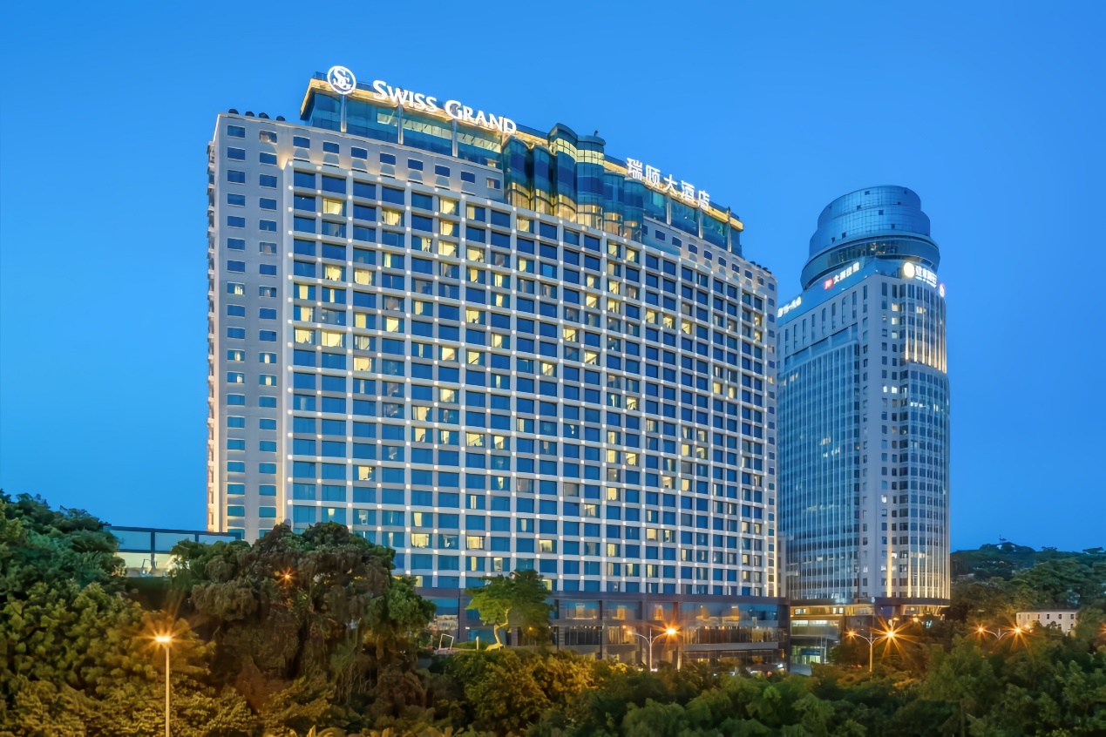
Group rates (including taxes):
- City View King / Twin Room: CNY 500 / night (1 breakfast included)
- Deluxe Gulangyu King / Twin View Room: CNY 600 / night (1 breakfast included)
(Additional breakfast: CNY 100 / person)
Service Languages: Chinese & English
Booking: Please send your reservation request to Reservation@swissgrandxiamen.com.cn and copy the email to Andy.wang@swissgrandxiamen.com.cn.
Please mention “iCEBDA 2026” in the email subject line, and specify your room preference (smoking or non-smoking room). If you do not receive a confirmation within 24 hours, please follow up with violetchenxmu@gmail.com.
Payment: Fees can be paid upon check-in using cash or credit cards, such as Visa and Mastercard.
Feature: SWISS GRAND XIAMEN faces the Gulangyu Island and enjoys a prime city location on Xiamen Island, about 15 minutes’ drive to the conference venue.
Address: 12 Lujiang Road, Siming District, Xiamen, 361001, China 福建省厦门市思明区鹭江道12号
More details please refer to https://www.swissgrandxiamen.com.cn/en/rooms (no group rate for this link).

2. HOTEL INDIGO XIAMEN HARBOUR
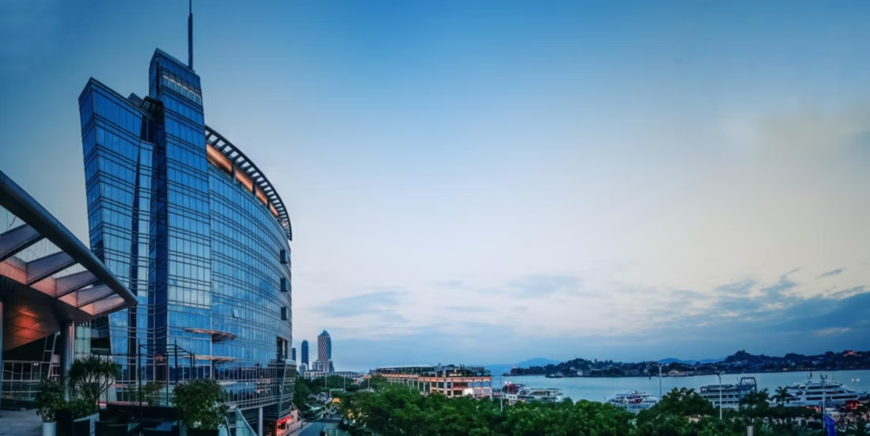
Group rates (including taxes):
King / Twin Premium City View Room: CNY 500 / night (2 breakfasts included)
Service Languages: Chinese & English
Booking: Hotel Indigo Group Rate
Payment: Fees can be paid using cash or credit cards like Visa and Mastercard.
Feature: Managed by InterContinental Hotels Group, Hotel Indigo Xiamen Harbour is the global branded boutique hotel located in Xiamen’s CBD, featuring panoramic views of the city’s harbour and scenic Gulangyu Island. It’s about 15 minutes’ drive to the conference venue.
Address: 16 Lujiang Road, Siming District, Xiamen, 361001, China福建省厦门市思明区鹭江道16号
More details please refer to https://www.ihg.com/hotelindigo/hotels/gb/en/xiamen/xmnin/hoteldetail (no group rate for this link).

3. HOTEL LIM (CAMPUS HOTEL)
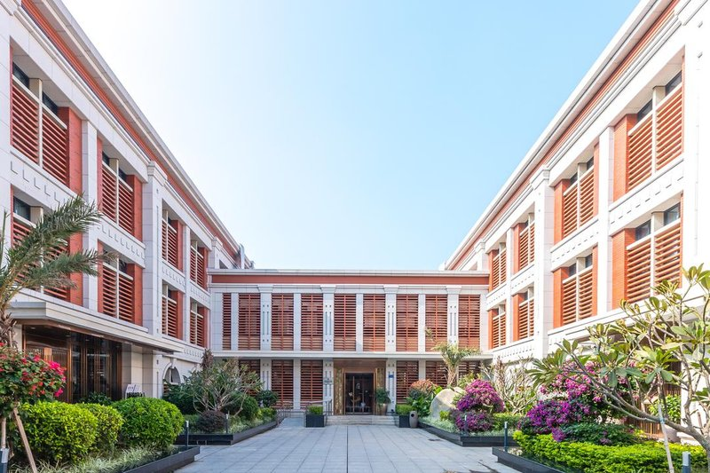
Group rate (including taxes):
- King Room: CNY 500 / night (2 breakfasts included)
- Twin Room: CNY 500 / night (2 breakfasts included)
Service Language: Chinese & English
Booking: https://v.wjx.cn/vm/Qzu0zJv.aspx
Payment: Fees can be paid upon check-in using cash or credit cards, such as Visa and Mastercard.
Feature: A 4-star standard hotel on campus, about 5-8 minutes’ walk to the conference venue.
Address: 422 Siming South Road, Siming District, Xiamen, 361001, China福建省厦门市思明区思明南路422号厦门大学林梧桐楼酒店（近大南校门）
More details please refer to http://hotel485018.round-world-trip.com/en (no group rate for this link).

