Registration & Payment
Standard Rate: 300 USD (2,000 CNY) / person;
Student Rate: 180 USD (1,200 CNY) / person

I. Payment by QR code (for all participants)
If you have an Alipay, WeChat Pay, or Chinese bank account, please scan the QR code below to pay the registration fee (in CNY only).
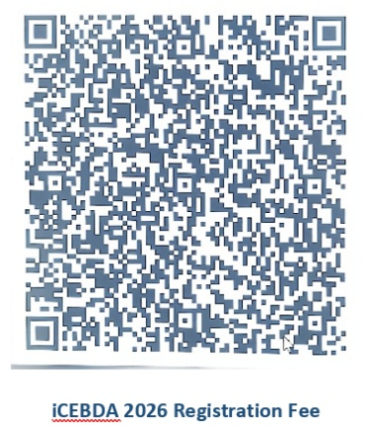

II. Payment by international bank transfer (only for overseas participants)
The bank account below accepts both USD and CNY. If you pay the registration fee via international bank transfer, please ensure you complete the Remittance Information field so we can track and verify your payment. Once complete, kindly upload your payment receipt to the registration form.
Bank transfer details:
Beneficiary's Bank | BANK OF CHINA XIAMEN BRANCH  (中国银行厦门市分行)
Beneficiary's A/C No. | 428658381176
Beneficiary's Name | Xiamen University  (厦门大学)
Beneficiary's Address in China and Telephone Number | Office of Financial Affairs, Xiamen University  Siming South Road, No. 422, Siming District, Xiamen  0086-0592 2183540
Remittance Route (Swift) | BKCHCNBJ73A
Remittance Information | iCEBDA 2026 Registration Fee

If you have any difficulty completing the bank transfer, please contact violetchenxmu@gmail.com directly — it is possible to arrange payment by credit card in person during on-site registration in Xiamen.

